Software Design Specification: Theater Ticketing

By: Luis Suarez, Hailun Xu

# System Description

The system to be constructed will be a ticketing service for an AMC theater as well as providing a subscription to a premium viewing service. It will allow customers to buy tickets online and earn reward points as well as allowing administrators to manage customer profiles. It will have verification systems to prevent scalping and botting.

# Software Architecture Overview

The architecture diagram of all major components is the following:

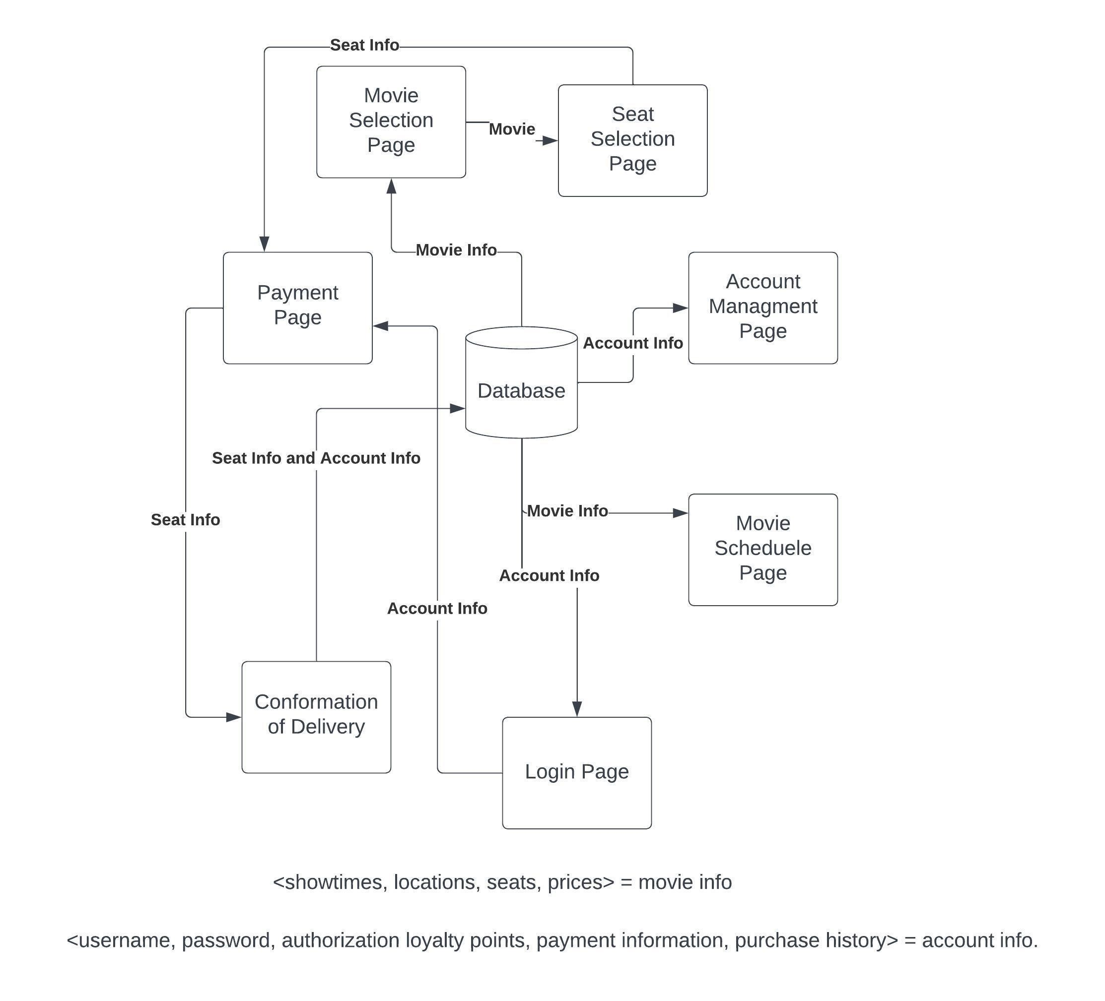

To purchase a ticket for viewing, the user must first have an account. They begin on the Movie Selection Page, whose info is updated from the database. Once they choose a movie, they are brought to a Seat Selection Page where they can choose a seat if any are available. Then they are brought to a Payment Page. If they are not logged in already, they are taken to a Login Page to do so. Once they have decided on the number of tickets to purchase and decide to check out, the system will go to the user’s credit card info in the database and query their bank to make sure it is a valid transaction. If so, the user gets a confirmed delivery form the Conformation of Delivery Page.

The user also has the option of managing their account on their Account Management Page and seeing the schedule of films available from the Movie Schedule Page.

# UML Class Diagram

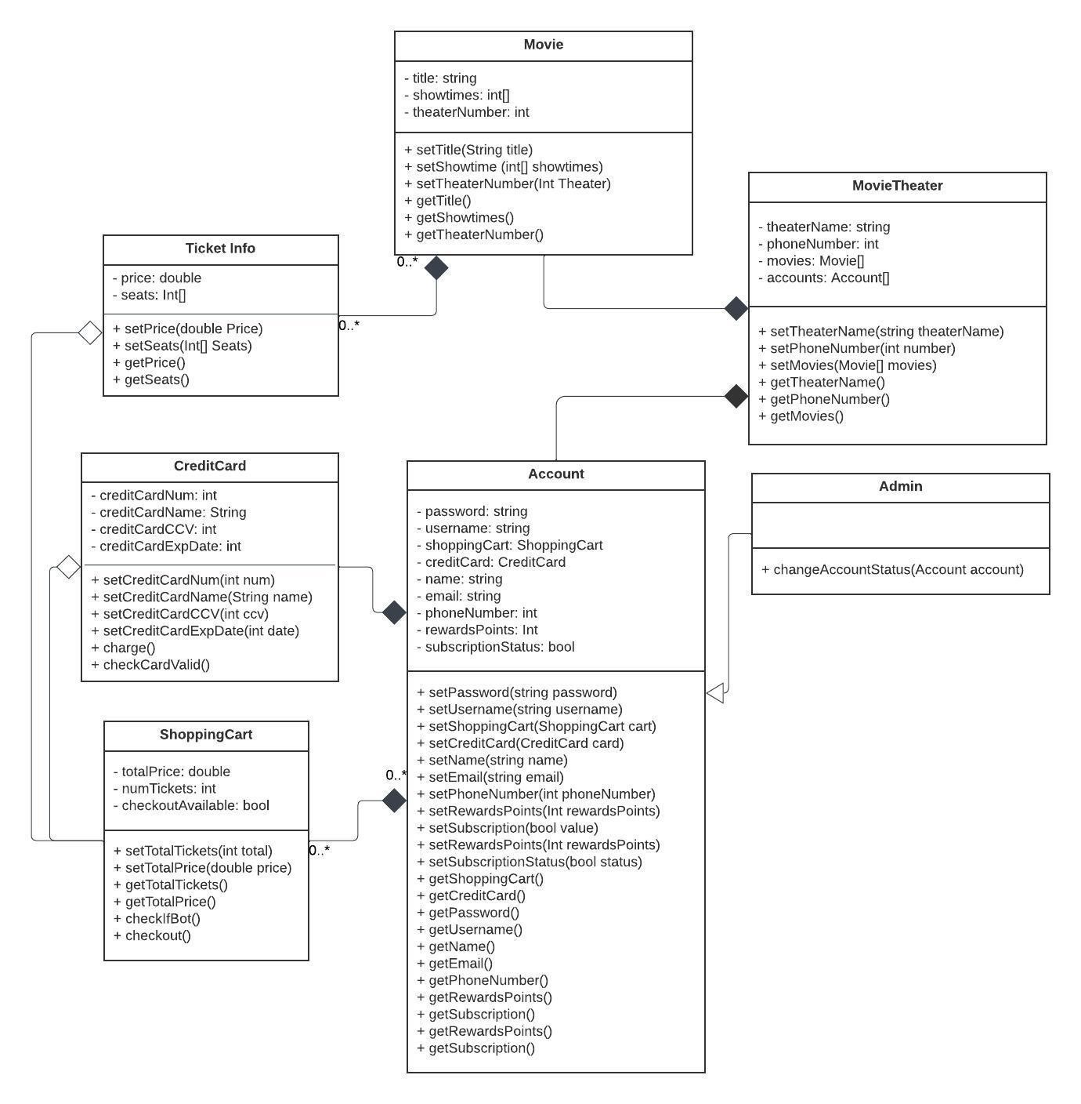

# Classes, Operations and Attributes

MovieTheater [class]: This is the movie theater. It has a string name, an integer phone number, a collection of user accounts using an Account array, and an array of movies containing Movie objects to show.

* setTheaterName(string theaterName) sets the name of the theater to the inputted string.
* setPhoneNumber(int number) sets the theater’s number using the inputted integer with no spaces, dashes or symbols, IE 9191119999.
* setMovies(Movie[] movies) updates what movies are available to be shown and takes in an array of movies.
* for each of these methods, there is a corresponding get() method.

Movie [class]: This is a movie that will be shown. It cannot exist without a theater. It has a title, which is a string, an integer array of showtimes, and an int that tells you which theater it is playing in.

* setTitle(string title) updates the title with the inputted string.
* setShowTimes(int[] showTimes) takes in an integer array with the showtimes. Times are formatted in 24-hour format. An example would be [0800,1200,1700] for 8am, 12pm, and 5pm respectively.
* setTheaterNumber(int theaterNumber) takes in an integer denoting the theater number. - for each of these methods, there is a corresponding get() method.

TicketInfo [class]: This class updates ticket information for a particular Movie. It shows the price as a double and the seats available as a collection of integers, with each seat labeled by a number.

* setPrice(double Price) updates the price with the inputted double.
* setSeats(Int[] Seats) updates the array of available seats. An unavailable seat will be set to “0” in the array.
* getPrice() returns the current price.
* getSeats() loops through the array and checks if the index contains a 0. Any seat that is not a 0 gets added to a new array of integers and the new array is returned.

Account [class]: This is a user account. It cannot exist without a theater. It has the person’s real name, username, password, email address which are all strings, and subscription status which is a boolean. It has their phone number and reward point count which are integers. It also has a shopping cart that they can use to buy movie tickets or an AMC subscription.

* setName(string name) takes in a string as the person’s name.
* setPassword(string password) takes in a string as a password. Any password less than 8 characters is not accepted.
* setUsername(string username) takes in a string as a username. it must be a minimum of 4 characters in length.
* setEmail(string email) holds the user’s email address.
* setPhoneNumber(int number) sets the user’s number using the inputted integer with no spaces, dashes or symbols, IE 9191119999.
* setRewardsPoints(int rewardsPoints) updates the number of rewards points this user has.
* setSubscriptionStatus(bool status) determines whether the user is subscribed to the AMC service.
* setShoppingCart(ShoppingCart cart) updates the user’s shopping cart to the inputted cart.
* for each of these methods, there is a corresponding get() method.

Admin [class]: This is an administrator. it extends the Account class. Administrators can attend screenings and earn rewards like regular customers, but they have the ability to affect other Accounts.

* changeAccountStatus(Account account) allows an administrator to change some aspect of a customer’s Account, like subscription status or password, or to ban certain accounts from buying tickets if necessary. returns void.

ShoppingCart [class]: This is a shopping cart. It can’t exist without an account. It keeps track of the total price of tickets or a subscription using totalPrice, which is a double, and the number of tickets being bought via the integer numTickets. It also deters bots and scalpers. The boolean checkoutAvailable can disable checkout if needed.

* setTotalTickets(int total) updates the cart based on the number of tickets being bought, which can’t exceed 20. Calls TicketInfo.getSeats() when the ShoppingCart is created to update how many tickets are available.
* setTotalPrice(double price) updates the amount due based on the number of tickets, and whether a subscription is being bought.
* for each of these methods, there is a corresponding get() method.
* checkIfBot() runs an algorithm at checkout time that determines if the user is a bot. If true, checkoutAvailable is set to false and checkout is unavailable. Then returns boolean true.
* checkout() calls checkCardValid() on the user’s CreditCard and checkIfBot(). If the Account’s card is valid and the user is not a bot, call charge() on the CreditCard. Otherwise checkout is disabled. returns void.

CreditCard [class]: The card on file for a user. It can’t exist without an Account. It has methods to set card info but no public methods to get any of it, to protect the user. The credit card number, expiration date, and CVV number are all stored as integers. The name is stored as a string.

* setCreditCardNum(int num) inputs the 16-digit credit card number as a single integer with no spaces. It will only accept an integer of this length.
* setCreditCardName(String name) stores the full name of the user in a string.
* setCreditCardCVV(int ccv) stores the 3-digit CVV as an integer.
* setCreditCardExpDate(int date) The date is stored as a four-digit number, MMYY.
* checkCardValid() contacts the user’s bank to see if sufficient balance is available and if card details are correct. Returns boolean false if there isn’t.

Development Plan and Timeline

The partitioning of plans for this project’s development will be:

Luis Suarez – Programming and Debugging:

Will be heading the programming, testing, and debugging for the project throughout its lifetime.

Hailun Xu – Programmer and Requirements Analysist:

Will be working alongside Luis S. in the programming for the project throughout its lifetime. Will also be heading the requirements analysis for the project.

A rough timeline of event will appear as such:

January 2023:

Planning

January 2023:

Requirements

February 2023:

Design

February 2023 – March 2023:

Software Development

March 2023:

Testing

April 2023:

Deployment

May 2023- June 2023:

Operations and Maintenance